Website content
Monica Moritsch, PhD
Overview
I am a marine biologist investigating opportunities for scaling climate change mitigation abilities of marine and coastal ecosystems. I have spent considerable time quantifying ecosystem services of marine and aquatic ecosystems around the world with the Environmental Defense Fund, US Geological Survey, the Marine Mapping Lab at Deakin University, Stanford Center for Ocean Solutions.
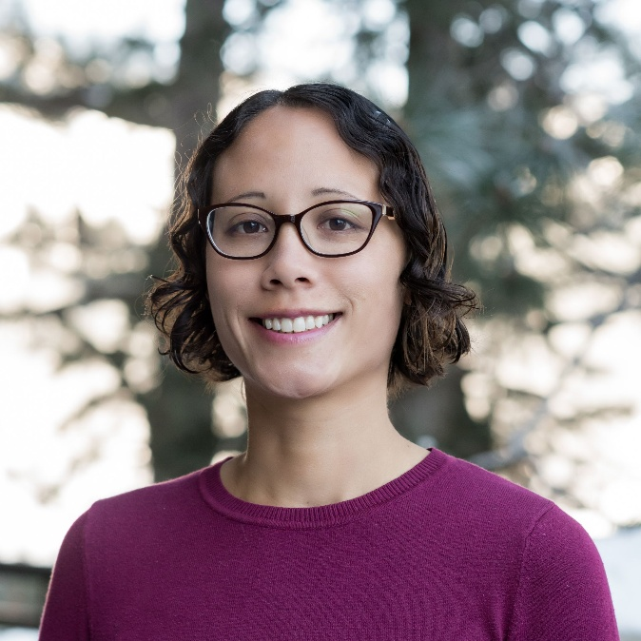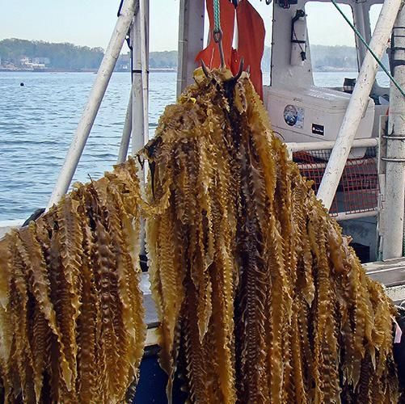
Background Information
Contact
Monica Moritsch (LinkedIn, Research Gate)
monicamoritsch @ gmail.com
Education
Ph.D. Ecology and Evolutionary Biology. University of California, Santa Cruz.
M.A. Ecology and Evolutionary Biology. University of California, Santa Cruz.
B.S. Molecular Environmental Biology. University of California, Berkeley.
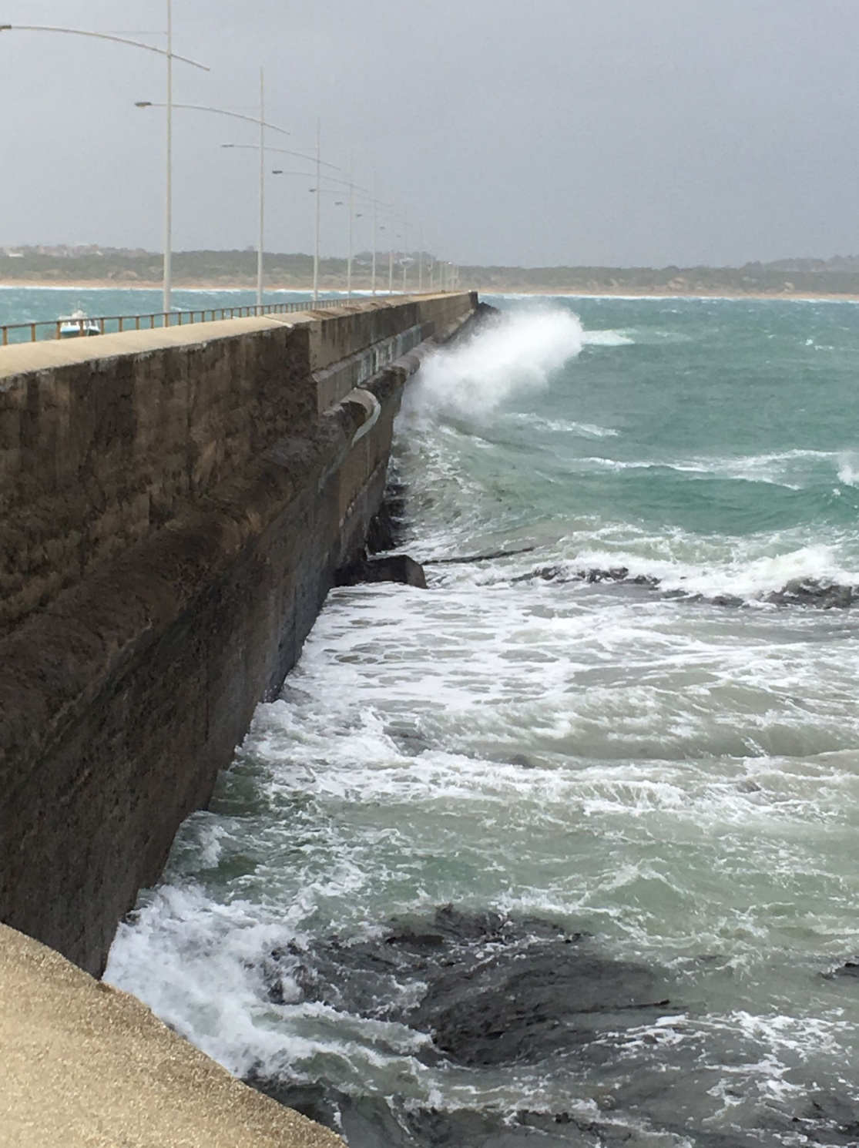
Ecosystem Services Modeling: Blue Carbon
At the USGS Western Geographic Science Center, I focused on modeling how sea level rise will impact the ecosystem services provided by marshes and tidal forested wetlands of the Pacific Northwest. Focusing on soil carbon, I used GIS and soil models to project changes in carbon sequestration. The results will inform the Billy Frank Jr. Nisqually National Wildlife Refuge as they draft their climate adaptation plans and make decision on how to manage the bird, fish, and plant species that rely on the refuge.

I have also modeled carbon sequestration in marine ecosystems (so called 'blue carbon') of Victoria, Australia as part of a joint postdoctoral research opportunity with Deakin University and University of California Santa Cruz. I compared carbon sequestration in mangroves, tidal marshes, and seagrass ecosystems under different management scenarios. The Victorian government is currently using the resulting maps to prioritize areas for habitat conservation and their broader marine spatial planning effort. The blue carbon estimates contributed to Australia's larger Mapping Ocean Wealth effort, which estimated the value of a series of ecosystem services associated with marine ecosystems.
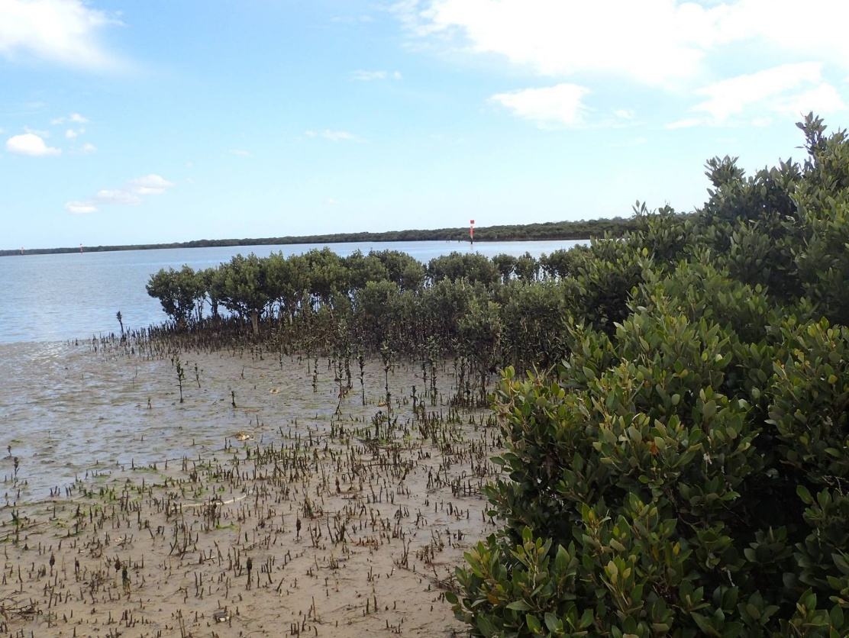
To view maps for blue carbon in Victoria in the Mapping Ocean Wealth portal, click on Regional Planning (Globe icon) > Regional Datasets > Australia > Blue Carbon. Right: Photo courtesy of Ashley Whitt.

Ecosystem Services Modeling: Coastal Protection
During my time at Center for Ocean Solutions, I modeled how California’s coastal habitats would store carbon and how they would mitigate flooding driven by sea level rise. I mapped where people and infrastructure were vulnerable to flooding under different levels of climate change severity as part of the Realizing Environmental Innovations Program.

Our goal was to aid California's coastal jurisdictions in prioritizing natural habitats and climate adaptation in their Local Coastal Plan updates. I performed geospatial analyses and translated scientific information for interdisciplinary team of environmental policy experts, modelers, software developers, and biologists.
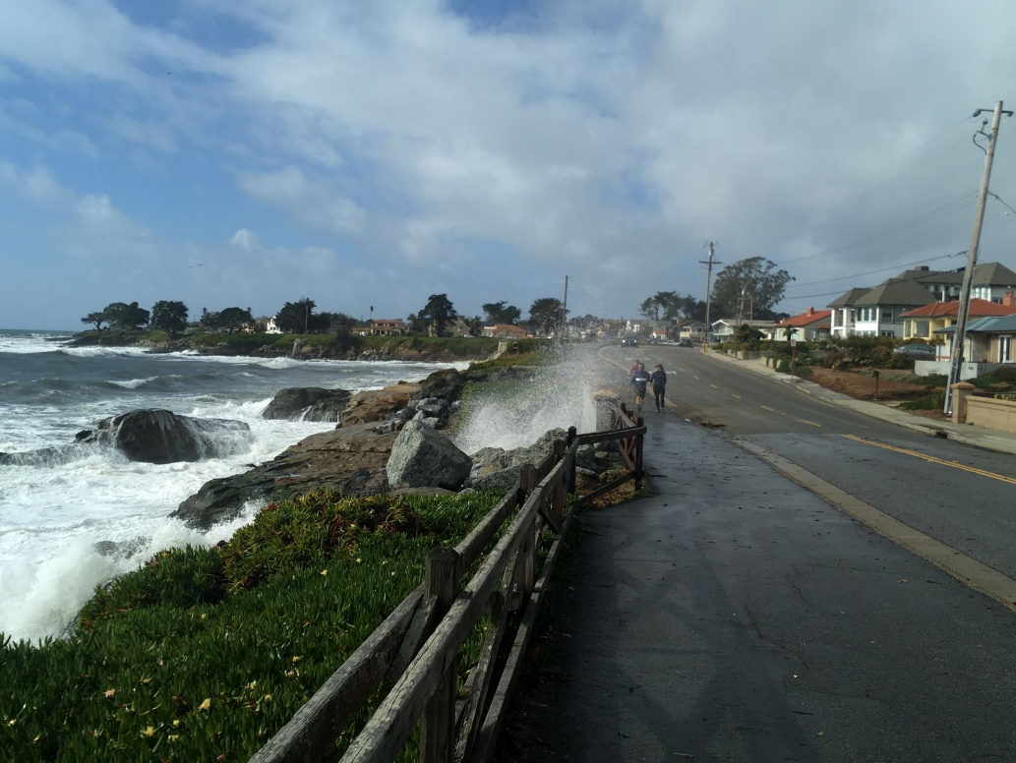
Map Production and Cartographic Services
I make visually appealing maps to get your message across. I have 12+ years experience in GIS and cartography, producing publication-quality maps. My work ranges from simple and elegant to complex, multi-layered panels to cleanly convey a wealth of detailed information. Example services include:
- Business locations and street intersections maps
- Site directories (grids)
- Trail system maps
- Drone and satellite maps
- Hotspot maps
- ESRI Story Maps and content creation
- Geographic data analysis
- Figures for scientific publications and reports
- Custom GIS workflows to streamline updates
- And other formats!
Please email me at monicamoritsch @ gmail.com to discuss your project.
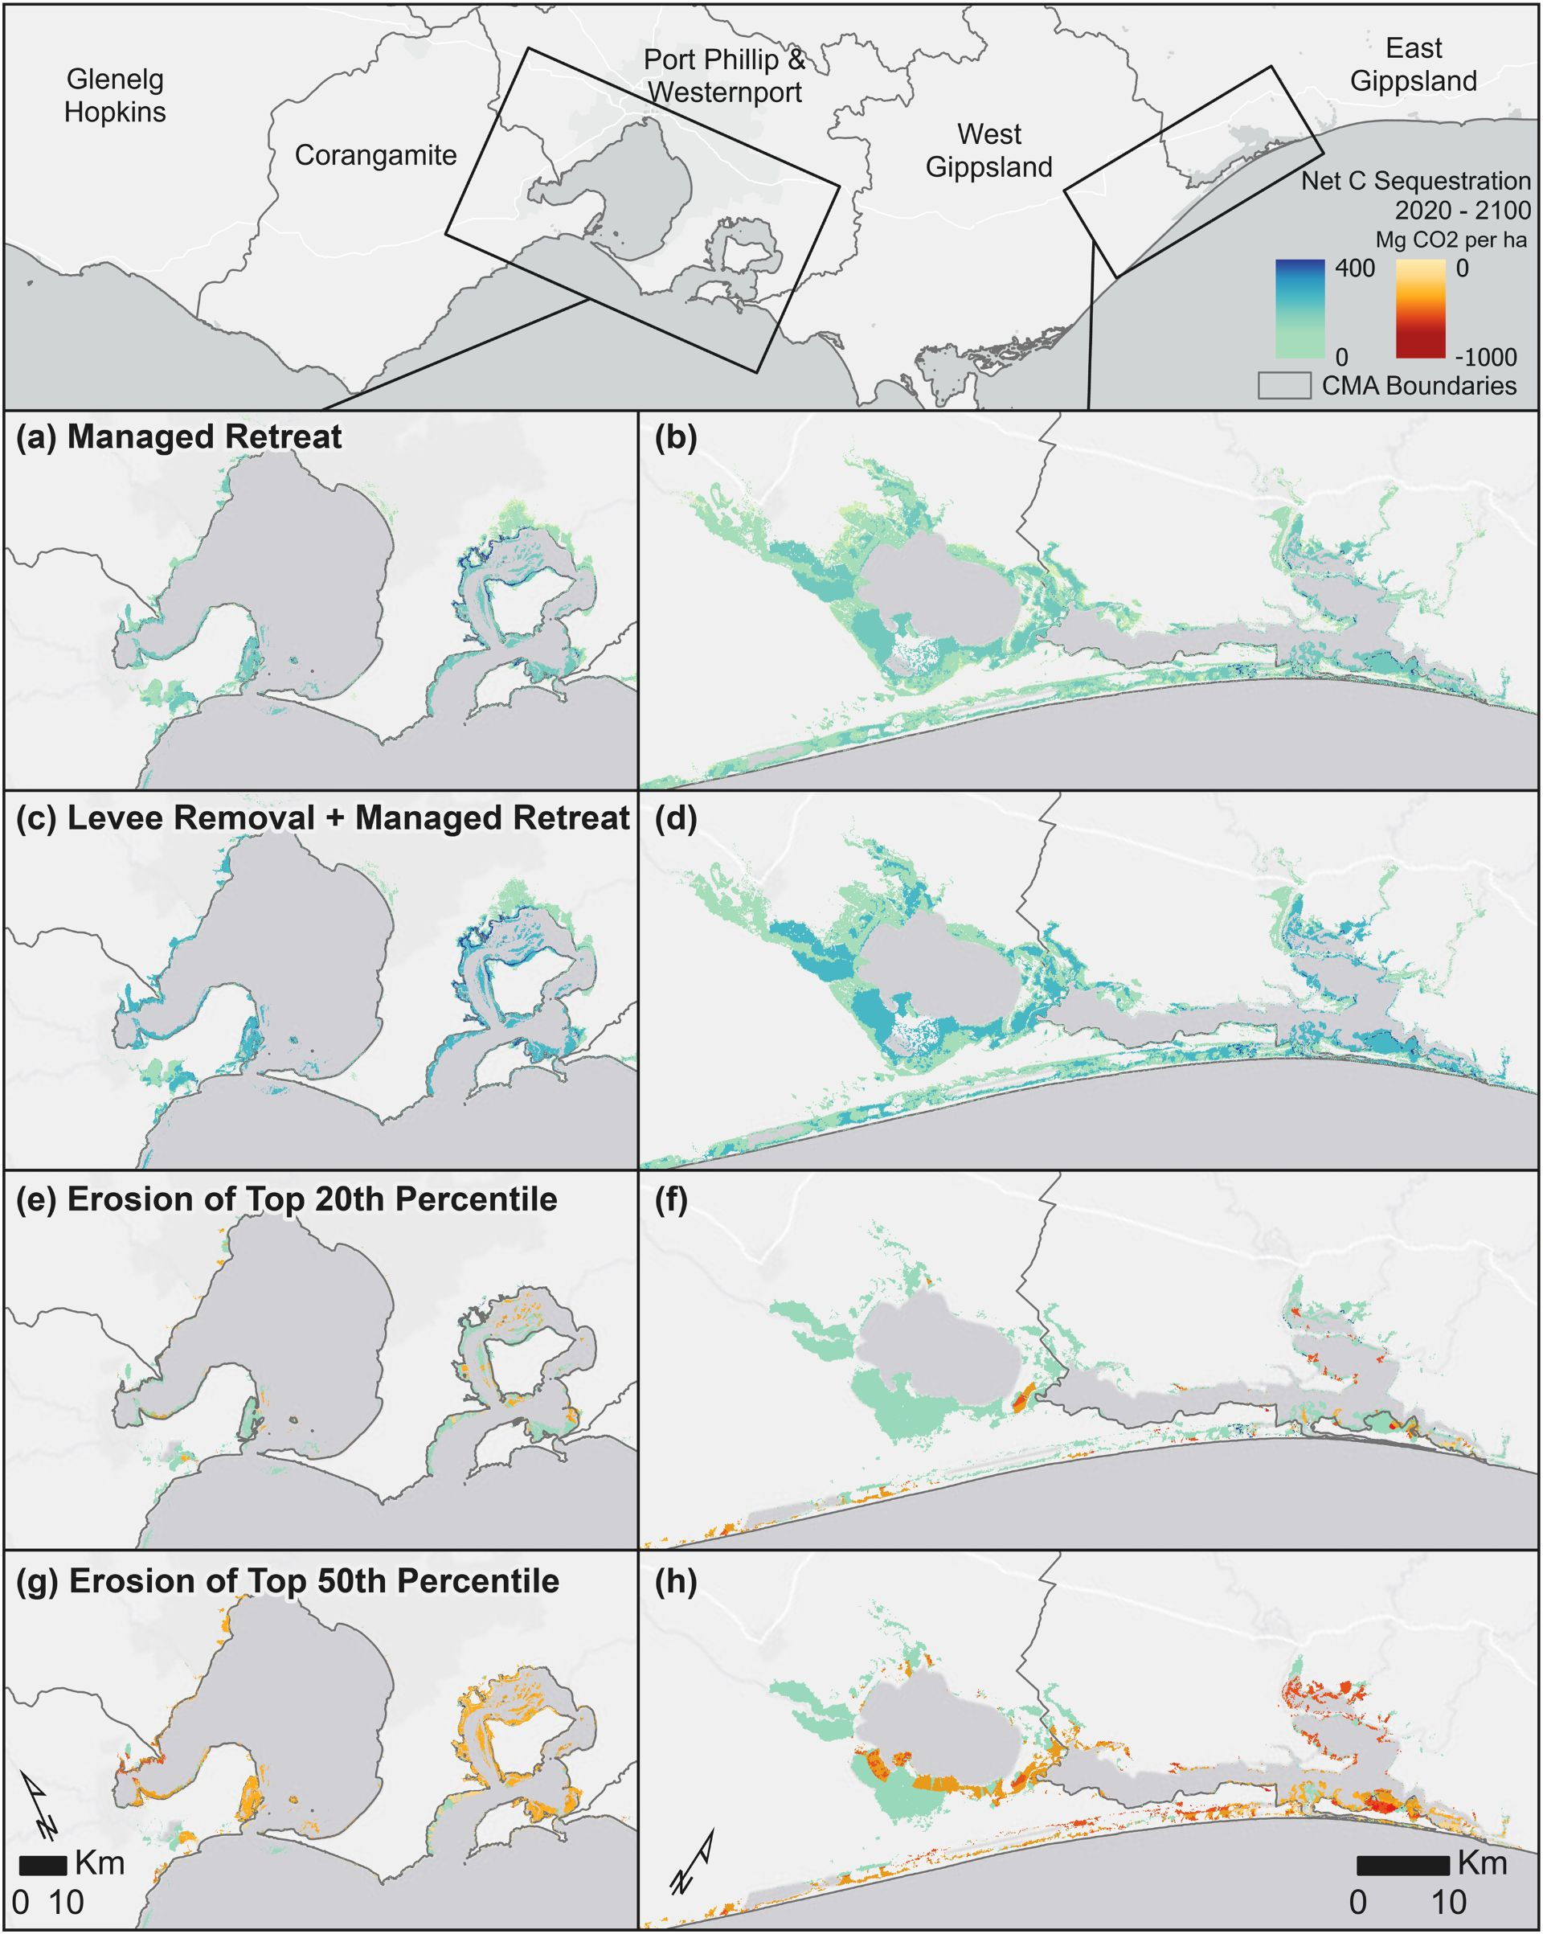
Example from Moritsch et al. 2021. Science of the Total Environment, 777: 145962.

Identifying environmental conditions surrounding a marine epidemic
I began my science journey at University of California Santa Cruz, where I earned my PhD studying intertidal ecology with the Raimondi-Carr Lab. I investigated which environmental and anthropogenic factors are associated with appearance of Sea Star Wasting Syndrome (SSWS). It is currently unknown what causes wasting syndrome; these outbreaks could stem from exposure to pathogens or environmental stressors, alone or in combination. A myriad of factors could contribute to sea star health, but researchers do not yet know which ones are most important.
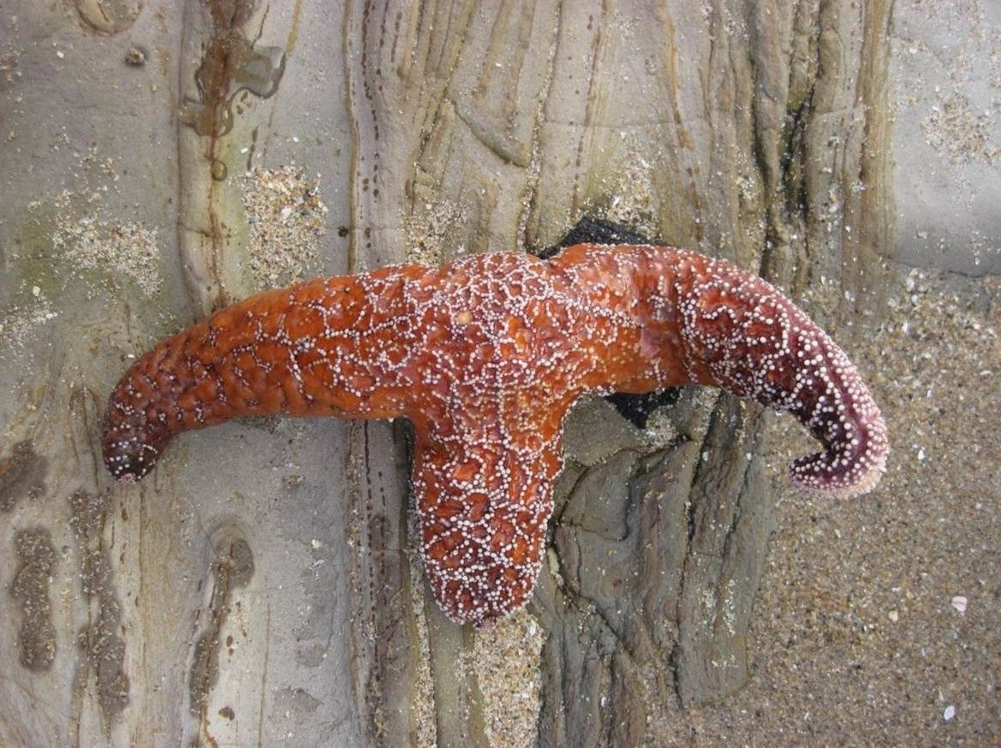
A sea star in the process of deterioration from Sea Star Wasting syndrome.

Using GIS to integrate data from the North American Pacific Coast, I used disease observations from intertidal monitoring and citizen science reports to search for correlations of disease presence with environmental patterns (above-average temperatures, prior sea star population density, low tide exposure times) and anthropogenic factors (coastal wastewater outfalls, human population centers, etc.). Identifying the factors associated with wasting syndrome presence can provide information on potential causes and mechanisms of spread, while de-emphasizing factors that did not seem to influence the outbreak.

Beach Visitor Knowledge of Marine Reserves
I am also interested in the human aspects of conservation: namely, what factors promote or hinder behavior for positive environmental outcomes. Tens of thousands of people visit California Marine Protected Areas (MPAs) each year because they treasure these habitats, yet this paradoxically presents challenges for ensuring visitors are sensitive to their impacts on these areas.
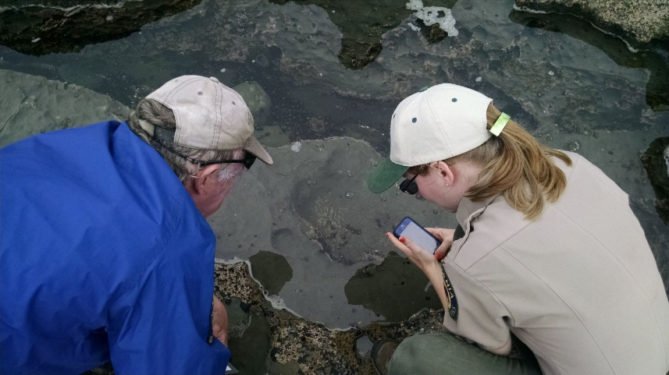
California State Parks Staff and a beach visitor curiously examine life in a tidepool at Natural Bridges State Beach.

To understand what the public knows about our local MPAs, we surveyed over 650 visitors at Santa Cruz County beaches. We found visitors generally supported the practice of environmental etiquette by abstaining from fishing, properly disposing of trash, and following signs. Most visitors stated they would follow existing protection measures if they knew they were inside of a MPA. However, many beach-goers did not know where the MPAs were. Over half of survey participants had heard of marine reserves, but less than one third of them knew whether they were standing inside of a reserve. This highlights a disconnect between awareness of reserve existence versus their specific locations. To help remedy this disconnect, my colleagues and I have reached out to local State Parks and MPA education groups that are equipped to educate large numbers of visitors.
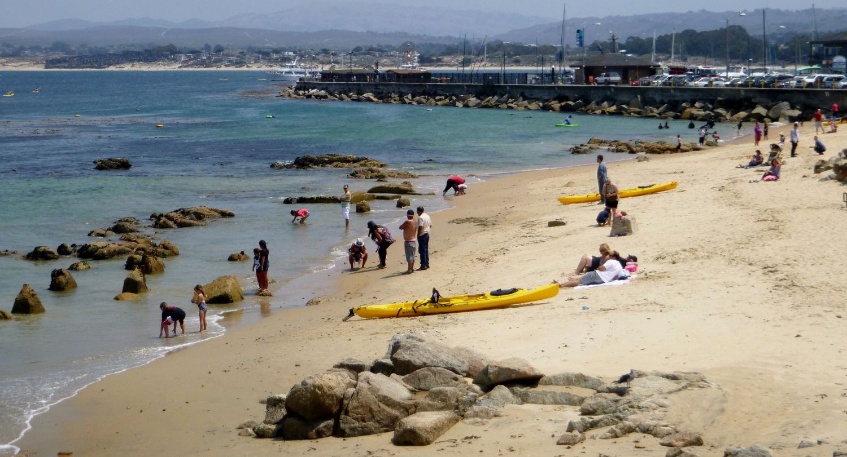
Monterey Bay Marine GIS User Group Leadership Board
I am on the leadership board for the Monterey Bay Marine GIS User Group, a professional networking organization supporting GIS training, capacity building, and increased awareness of marine and coastal spatial data sets among the broader GIS science community. I organize the annual conference by reaching out to venues and speakers to assemble a day of talks around a central theme in emerging geospatial research.
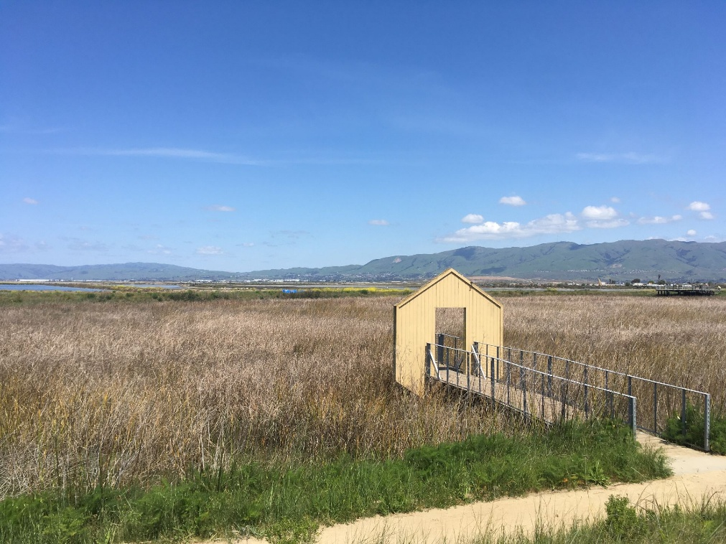
Publications
